Positive Negative Power Supply

Introduction

This power supply is one of the methods that you can use to design a negative and positive power supply:

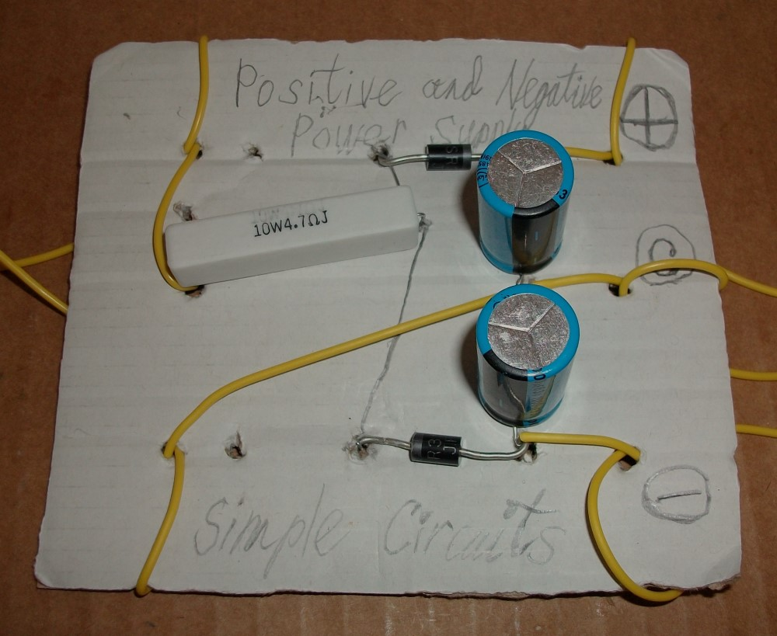
Figure 1: Power supply circuit.

Design the Circuit

I used Schotcky diodes that have a low forward bias voltage. There is one risk with this circuit. Each diode has a maximum breakdown voltage. This reverse breakdown voltage can cause high current to flow from Vn to Vp. However, this voltage is usually no less than about 100 V. Tuhs you have nothing to worry about.

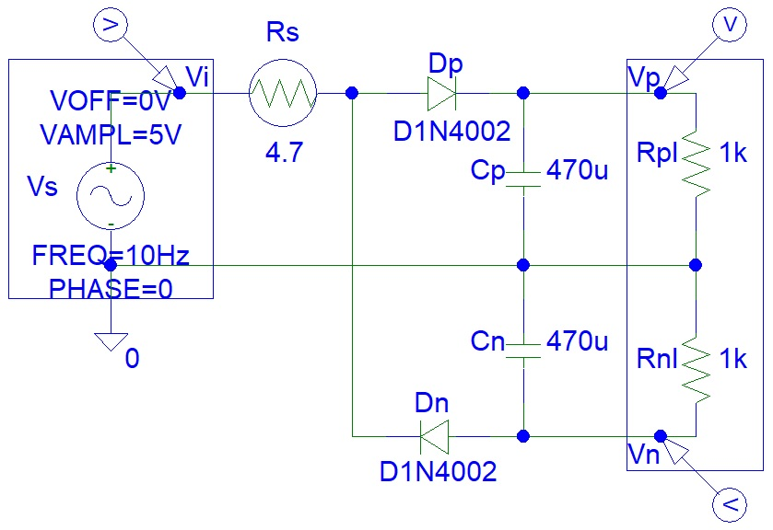
Figure 2: Circuit design

3. Simulations

PSpice simulations:

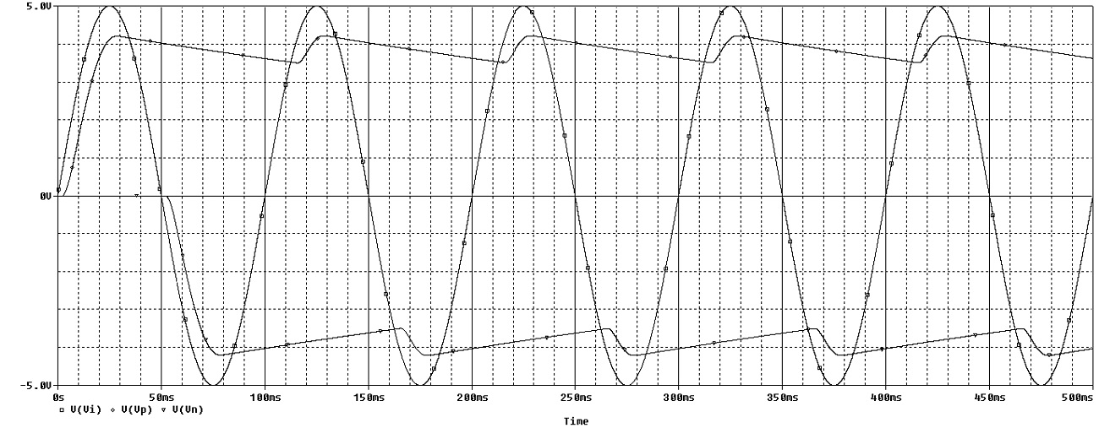
Figure 3: Circuit output was tested for a minimum frequency of 10 Hz.

Make the Circuit and Testing

Testing video is shown here:

https://www.youtube.com/watch?v=f0NyDAnF8LY

